PARGESS Post-Exercise Summary – Exercise Cloudless Dawn I - v1.3

Aim

PARGESS demonstration of response to an extended State-wide Internet outage during a Peel-area emergency.

Scenario

WA suffers a complete Internet outage as a result of a cyber attack. With nearly all communications in Western Australia in some way reliant on the Internet, all communications required for the existing emergency operation is lost. Coincidentally, collapse of the Mandurah Bridge (with casualties) triggers an emergency response from the Mandurah Police, Mandurah SES, Rockingham SES, and the Peel Health Campus. An Emergency Control Centre and an Emergency Evacuation Centre is established along with a logistics support team at the Murryfield aerodrome.

The City of Mandurah Emergency Coordination Centre¹ at Police Headquarters asks PARGESS to muster its volunteers to provide basic communications for the most critical nodes of the emergency operation. As a first response, voice and if possible, email communication (including digital attachments) was required between the following centres:

- City of Mandurah Emergency Coordination Centre
- Mandurah SES Headquarters
- Rockingham SES Headquarters
- Peel Health Campus
- Emergency Evacuation Centre
- Murrayfield aerodrome

Responding to the communications and Internet outage, PARG members monitoring the SES Headquarters-located PARG repeater are called to action, assembled at the SES Headquarters, briefed and deployed to locations required to assist with basic emergency communications to the best of their ability and in response to the local Commanders at each centre. PARGESS members are briefed to use the most appropriate non-Internet communication methods to pass messages between their local Commander and their intended destination in a timely manner. PARGESS members are briefed to also log: message numbers, message topic, time sent and the time acknowledgements are received from each destination³.

Exercise Implementation

PARGESS deployed 14 members to the various requested locations, and to PARG1, the Emergency Communications trailer which was deployed to Halls Head.

In parallel, one member remotely located acted as Message Control, to inject scenario-specific messages at pre-determined times.

Personnel from the Mandurah Police and the Mandurah SES provided support during the exercise with both message responses and appropriate scenario message injections.

Exercise Progress

The Exercise started on time at 0945 local time Sunday April 10th 2022 with a roll call, and assistance to stations experiencing technical problems with the WinLink messaging system.

The scenario started on time at 1000 with a call via amateur channels advising the Mandurah Police of the bridge collapse.

Message injection by Message Control (Exercise staff) worked well. 59 messages were injected in sequence and on-time – but some of the 59 were sent in advance to three operators who did not expect to have email available on the day. One operator receiving the advance messages was unable to determine the timing or sequence required on the day.

Final recipients of each message used their experience (for the Police and SES participants) and initiative (for operators) to respond to each with replies by follow-on messages, as would normally happen in an emergency, and continue the scenario to a logical conclusion.

The Exercise was called at 1230 local time by the Operations Director, even though many of the initiated messages had yet to be passed.

Exercise Management

The PARG1 emergency communications trailer was manned with the Exercise Director, PARG1 Supervisor and two radio operators. The Supervisor and operators coordinated message handling well between the deployed operators to help manage frequency congestion.

Operators used tactical call signs for local communications, and identified with their own amateur call signs per their license requirements. Normal call signs were to be used on HF (because the calls were able to be received across Australia). Messages with content that could be mistaken for real situations were prefixed with “For Exercise”, “Exercise Cloudless Dawn”, etc.

Pre-Exercise Test

Prior to the exercise, PARGESS conducted a very successful communications trial to:
- verify the performance of various circuits and modes;
- provide members with exposure to message handling and frequency management; and
- address the Exercise Plan’s Risk Management treatments.

Debrief

PARG will host a debrief with the Local Emergency Management Committee.

Lessons from the exercise are summarised at the Attachment for consideration for future exercises.

Attachments
- Notable Post-Exercise Comments
- Lessons
- Looking Forward
- References

Comments

Post-exercise comments:

- Mark Bosma

Congratulations all - sounded to me that once the messages started flowing, the exercise went very well - and I was very impressed with the professional-sounding operators we had - outstanding!

I’ll be interested to see members’ comments by email.

Perhaps we should dedicate the next PARG meeting (after Easter - Tuesday April 19th) to a debrief and to get everyone’s thoughts on what worked, what didn’t, what we should do different next time, and thoughts on future exercises - aims, how often, variations, etc?

Geoff, Martin, Paul - thoughts on that as the topic for the meeting? Perhaps we could wind-in some sort of workshop concerning our portable stations, Baz’ trombone antenna, expanding our WinLink capacity (I’m only one lead away!), expanding the mesh network to make it deployable for message / image transmission, etc?

Cheers, well done all.
Mark Bosma
VK2KI / VK6QI
mark.bosma@icloud.com
0418161773

- Martin Diggens:

Hi All

Thank you to all for an amazing effort yesterday. Well done to you all.

Early feedback indicates that it was an excellent exercise with excited comments from Chris Stickland (SES manager), Ross Blake (Officer in Charge Mandurah Police) and Myra Giardini (Mandurah LEMC coordinator).

I will be contacting these people including the Peel Health Campus today for their thoughts on the exercise.

The VHF voice contacts worked very well and from my position in PARG1 the voice messaging people under the direction of Paul (VK6LL) were very busy keeping things under control. Well done to Paul, Peter, Jen and Josh. I was kept busy with the Winlink side of things. Each of the managers of the SES, Police and Hospital forwarded a special private message to me at PARG1 via UHF Winlink. I then relayed these messages back to the originator's normal email address via HF through VK3MIT Winlink RMS station near Melbourne, where the messages were injected into the internet mail system. Chris at the SES was blown away when the email he sent out on UHF appeared on his phone some minutes later. 20 mtrs to Melbourne was very strong and reliable. The messages went through with no delay. I was running around 100 watts into the rotatable HF dipole beaming towards the East at a height of 30 feet on the Clark mast.

I have heard that both the SES and Police managers were really impressed that email could be sent by radio. I understand that neither were aware that email can be sent over radio. I expect there will be some conversations with their respective organisations about this.

Here is a copy of the final email I sent as we were signing off at the end of the exercise. I cc'd a copy to my own email address to let me know that it had been received correctly:

PARG/LEMC EXERCISE ... NO ACTION REQUIRED

vk6arg@winlink.org
To:harvey*******@ramsayhealth.com.au, ross.*******@police.wa.gov.au, *****stickland@bigpond.com
Cc:myra***@mandurah.wa.gov.au, vk6mj@yahoo.com, mark.bosma@icloud.com, pgardner@bigpond.com

Sun, 10 Apr at 12:32 pm
Hi All

This is an email sent via Shortwave Radio on 14.102 Mhz to an email server in Melbourne from PARG1 at Calypso Rd reserve in Mandurah.

Thank you for your participation in this exercise.

We are coming to the end of the exercise and about to close down.

Best regards

Martin and the crew at PARG1

73

Also a big thank you to David VK6FAAZ and Paul VK6LL for many hours of working and composing the test messages and to Mark for countless hours of preparation for the event.

Thanks is also due to the PARG Winlink members: Terry, Maurice, Bruce, John and other members who are in the process of bringing their Winlink stations up on air, for their keen support and testing the system over the last few months.

So a big pat on the back to all concerned and PARG can feel proud of itself for the success of the event. We have proven our ability to provide emergency communications from critical emergency facilities in and around the Peel district.

P.S. can those of you who took photos send me some copies please?

Best regards

Martin

VK6MJ

- Chris Stickland:

Hi Martin,

Well done to yourself and all the PARG volunteers for the successful execution of yesterday's exercise. All objectives were successfully met and technical issues were quickly overcome. I was very impressed with the whole exercise and the capabilities of your group. I thought it was a valuable demonstration of what can be achieved. Your group has the ability to be of great value in supporting the emergency services in any major operation. Thank you for all the behind the scenes hard work that made this exercise such a success. Keep up the good work and it is a great comfort to us to know you and your volunteers can support us.

Kind regards,

Chris Stickland
Manager Mandurah SES

- Senior Sergeant Ross Blake

Good Morning All,

It was great chatting to Maurice and Graham yesterday, as they were looking after the ECC here at Mandurah Police Station. It was good to see first hand exactly how it would work.

I can also confirm I received emails at 12:10pm and 12:33pm.

I look forward to the debrief and further discussions going forward.

Regards

Ross

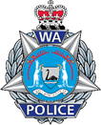
Senior Sergeant Ross Blake | 16044 | Officer In Charge
Mandurah Police Station | Western Australia Police Force
333 Pinjarra Road, Mandurah, WA 6210
T: (08) 9581 0222 | Direct T: (08) 9581 0220

- Myra Giardini

Morning Martin,
I hope all went well with the remainder of the communications exercise yesterday.
Please find the photos taken at Calypso Carpark attached, I can provide higher resolution if required.

Confirming that I received the 3 email messages at 11.35am, 11.47am and 12.30pm.
Please pass on our thanks to everyone who participated, both in the region and Melbourne.

LEMC will be very interested in the exercise feedback.

Kind regards

Myra Giardini |  | 
Coordinator, Emergency Management
Web | mandurah.wa.gov.au
Email | Myra.Giardini@mandurah.wa.gov.au
Phone | +61 (8) 9550 3211 | Mobile +61 (0) 408 941 003
Address | 3 Peel St, Mandurah WA 6210 | Post PO BOX 210, Mandurah WA 6210
 | The City of Mandurah acknowledges the Bindjareb people as traditional custodians of this land. We acknowledge and respect their continuing culture and the unique contribution they make to the life of this community.
 | Please consider the environment before printing this email

- Tony Boddy

Hello Martin,
My computer has gone to poop again. I really hate these things with a
passion. This one is Windows 7 and is probably on its last legs on
account it has become more and more useless as days go by. I have not
been able to get the ex SES laptop onto the internet and I'm thinking
maybe its time for me to chuck it all in and go back to writing where I
only need a word processor. Trouble is I sometimes need one for research.

In the mean time I have to give you a report on the Cloudless Dawn
because I will not be Zooming on the 19th. It seems that I missed out on
many things on the day. Preparation for that day gave me the gear to do
the job but after receiving two packets of messages in the wee small
hours of the morning, I could not make any sense out of them so all I
could do was arrange them in numerical order. I assumed that I would be
called and would be able to follow through with the scripted response.
Tell me another, that did not work!

There was no way that I could find a way to use the messages. Nobody
called me and I was not keen on getting what seemed to be a bit of a
failure out in front of official observers. I'll battle through and the
path will become clearer with participation. That did not work either. I
was confused by the numbers, eg, message numbers and message ID. I
listened and numbers turned up but were vastly different from the ones
on my paperwork. Some started with 40000****and some more. I got lost
chasing numbers on my papers and just found it difficult to log anything.

Finally I got a 2m message from Maurice and was told that the numbers
were out of sequence. He wasn't wrong there. I made one contact with
Terry on HF. The weakest VHF signal from where I was was Geoff and he
was too scratchy to resolve. By this time I was pretty frustrated and
almost pulled out. I did try to call net control several times but had
no reply. I was certainly glad when it was all over.

I found out later after speaking with Terry and Maurice that I was
supposed to receive a text with instructions on when to send the
messages emailed to me. A broken link in the comms chain? I certainly
received no Text. I did not manage to make a log on account I did
virtually nothing.

This seems to be the norm. From now on please do not include me in any
exercises, my level of skills is just not suitable for the tasks in hand
and I do not do frustration anymore.

Best regards,

Tony, VK6DQ.

Lessons

Title | Lesson | Importance to Overall Exercise | Resolution
Agency Participation. | Limited involvement by the external emergency management agencies. | Important
Message Injection. | Lack of external agency involvement meant planned message injection by email to those agencies could not be used. | Important.
Acknowledge-ment of relayed messages. | Most messages that were passed through multiple steps were not followed by return acknowledgement from final destination to originator. | Important.
Message Injection Confusion. | Member without email during the Exercise received advance-copy of messages before-hand, but was unable to make sense of the order and timing required on the day. | Minor
Not all messages passed. | Message sequencing difficulties and closure of the Exercise meant that not all of the 59 messages were passed. | Minor
Operator locations. | Operators working in their cars etc has limitations – better for operators to be inside headquarters buildings etc. | Minor
PARG1 location. | PARG1 was in a weather-exposed location. Replace manual operations with automated system (mesh, repeaters, WinLink digipeater, etc), location of comms coordination inside say SES? | Minor

Looking Forward

Outcomes of the 19Apr22 debrief meeting held with the City of Mandurah Emergency Coordinator, OIC Mandurah Police, Mandurah SES Manager and PARG members, held at the SES Headquarters and via Zoom videoconference.

What? | So What? | So What Now?
Mandurah Emergency Coordinator expressed interest in PARG applying for funding under the National Disaster Risk Reduction grant and similar, including support for the 50% self-funding caveat that goes with most similar grants. | Potential for funding for:  - Establishment of a PARG Comms Coordination Centre (eg a mezzanine office at the SES).  - New MESH server for future use with video, voice, file transfer, live data, on-line chat, etc.  - PARG-hosted Radio Message Service node.  - WinLink digipeater.  - Robust grab-kits for voice and WinLink. | - Establish a development plan.  - Apply for small grant in 2021-22 FY (eg mesh server replacement), attaching development plan.  - Source 50% offset funding (eg Mandurah Council, SES, FRRR, WIA, Bendigo Bank, Alcoa, Foundations, etc).  - Apply for full comms centre grant in FY 2022-23.
Mandurah Emergency Coordinator questioned PARG’s ability to provide such service in poor weather. | Consider options for poor weather mitigation. | - Establish Comms Centre for coordination (eg grant in 2022-23 to build facility at SES HQ).  - Have operators inside each location with internal or external antennas.
Mandurah Emergency Coordinator liked the idea of involvement of the wider amateur radio community. | Opportunity to build a more robust comms network by involving other WA amateurs | - Consider inviting other Clubs to participate in future events.
Mandurah Emergency Coordinator wanted greater involvement in future exercises by the client services. | Opportunity to make future exercises more meaningful by the client services providing the scenario messages (eliminating the PARG Message Control staff function). | LEMC to encourage client services active participation in future exercises.
Mandurah Emergency Coordinator advised of Council willingness to consider ad-hoc minor funding support – eg catering. | Demonstrates community spirit of Council. | Consider requests for support for future exercises, and for development of minor equipment, infrastructure, training and capability development requirements.
OIC Mandurah Police suggestion to formalise arrangements. | Set aside sites (including in-building) with limited infrastructure. | - Grant or Council support for minor infrastructure (eg antenna supports, etc)?  - Ask each location to provide support for specific requirements (eg commitment to make internal accommodation available, installation of antennas, etc)?
Mandurah Police interested in PARG’s future exercise directions. | Future engagement looks positive. | Keep LEMC in the picture.
SES Manager was very pleased with the exercise. | Future engagement looks positive. | Advise LEMC and SES Manager of interest in running or participating in future exercises.
SES Manager liked PARG’s flexibility and ease of set-up. | Leverage for future opportunities? | Grab-kits, etc to allow quick and reliable node establishment.
SES Manager liked PARG’s potential for inter-State communications. | Consider for greater involvement in future exercises. | Consider establishing our own Radio Messaging Service to compliment VK3MIT at Wangaratta.
SES Manager was interested to see more of PARG’s capabilities. | Future engagement looks positive. | Advise SES Manager of PARG’s interest in future SES exercises.
Most PARG members enjoyed the exercise. | Positive activity for the Group. | - Future combined exercises.  - Use LEMC to involve PARG in client services’ exercises.  - Look for related activities – eg support for public events (bike races, marathons, festivals, car rallies, etc).
Last exercise was three years ago. | Opportunity for more frequent activities. | - Future combined exercises.  - Use LEMC to involve PARG in client services’ exercises.  - Look for related activities – eg support for public events (bike races, marathons, festivals, car rallies, etc).
Technical competence of PARG members, but more message-handling experience required. | Opportunities for PARG to:  - provide better support  - to leverage members’ enthusiasm. | - Message handling training.  - Message handling exercises.  - Engagement of PARG in client services’ exercises.  - Future PARG-led combined exercises.
Limited WinLink experience among PARG members. | Opportunity to encourage more involvement in WinLink. | - Encourage more members to build and use WinLink.  - Make WinLink system and operations more understandable (eg workshops, training, etc).  - Promote WinLink use within PARG and with other Clubs (eg make the VK6JEN nets a permanent PARG activity (eg forth Tuesdays of the month).
Mesh system emergency support opportunities. | Potential for internet-free high-speed data and file transfer, audio, images, video. | - Determine how to use the mesh system in future demonstrations and exercises.  - Upgrade the mesh server to a state of the art robust system that will handle future data and video requirements.  - Consider putting the upgraded mesh server in the SES Headquarters for reliable power and internet.
Other amateur Radio Groups unable to do combined exercises to date. | PARG engagement in LEMC bearing fruit. | - Look for opportunities for more combined exercises (including PARG participation in clients’ exercises).  - Continued engagement with client services via LEMC.
Outstanding work by Martin, Paul before and during the exercise. | Membership enthusiasm has jumped. | - Leverage the opportunities presented to PARG and its members.  - Keep trying different variations on the theme (eg message handling, WinLink, exercise variations, public event support, development of the mesh system, comm centre, grab-kits, infrastructure, etc).

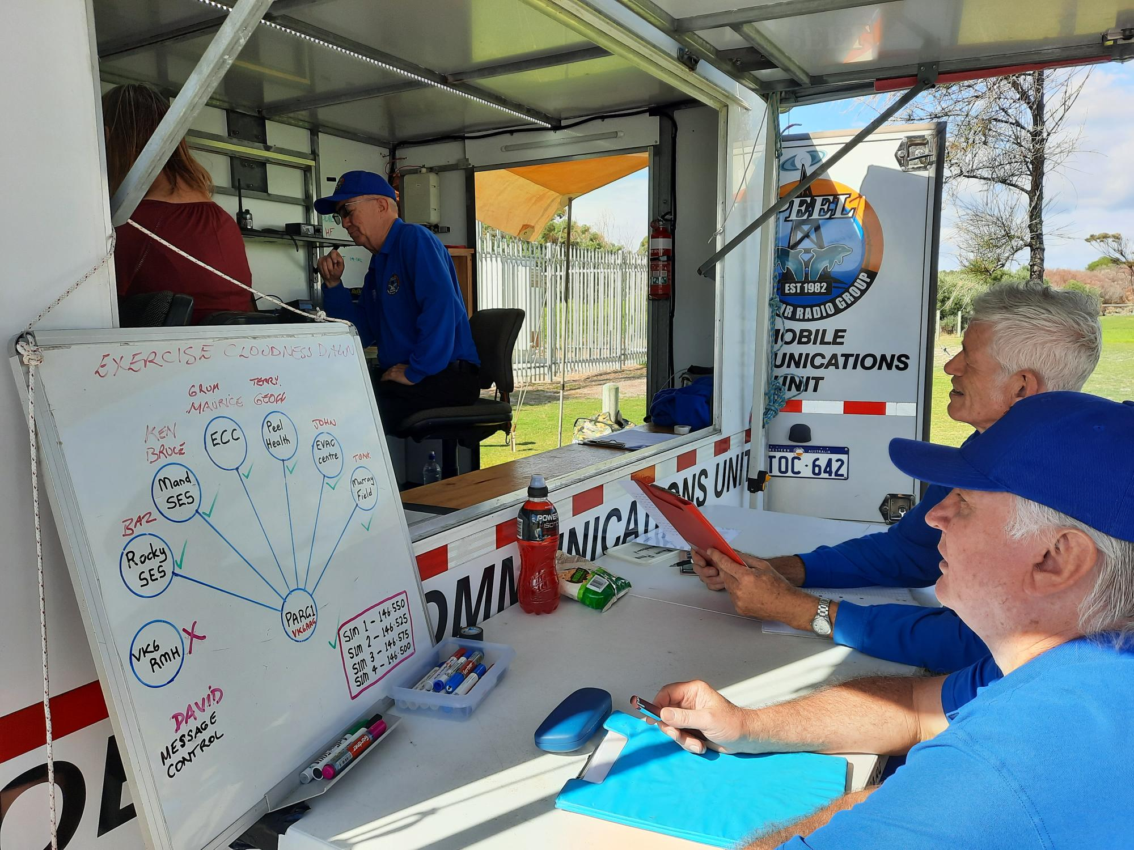
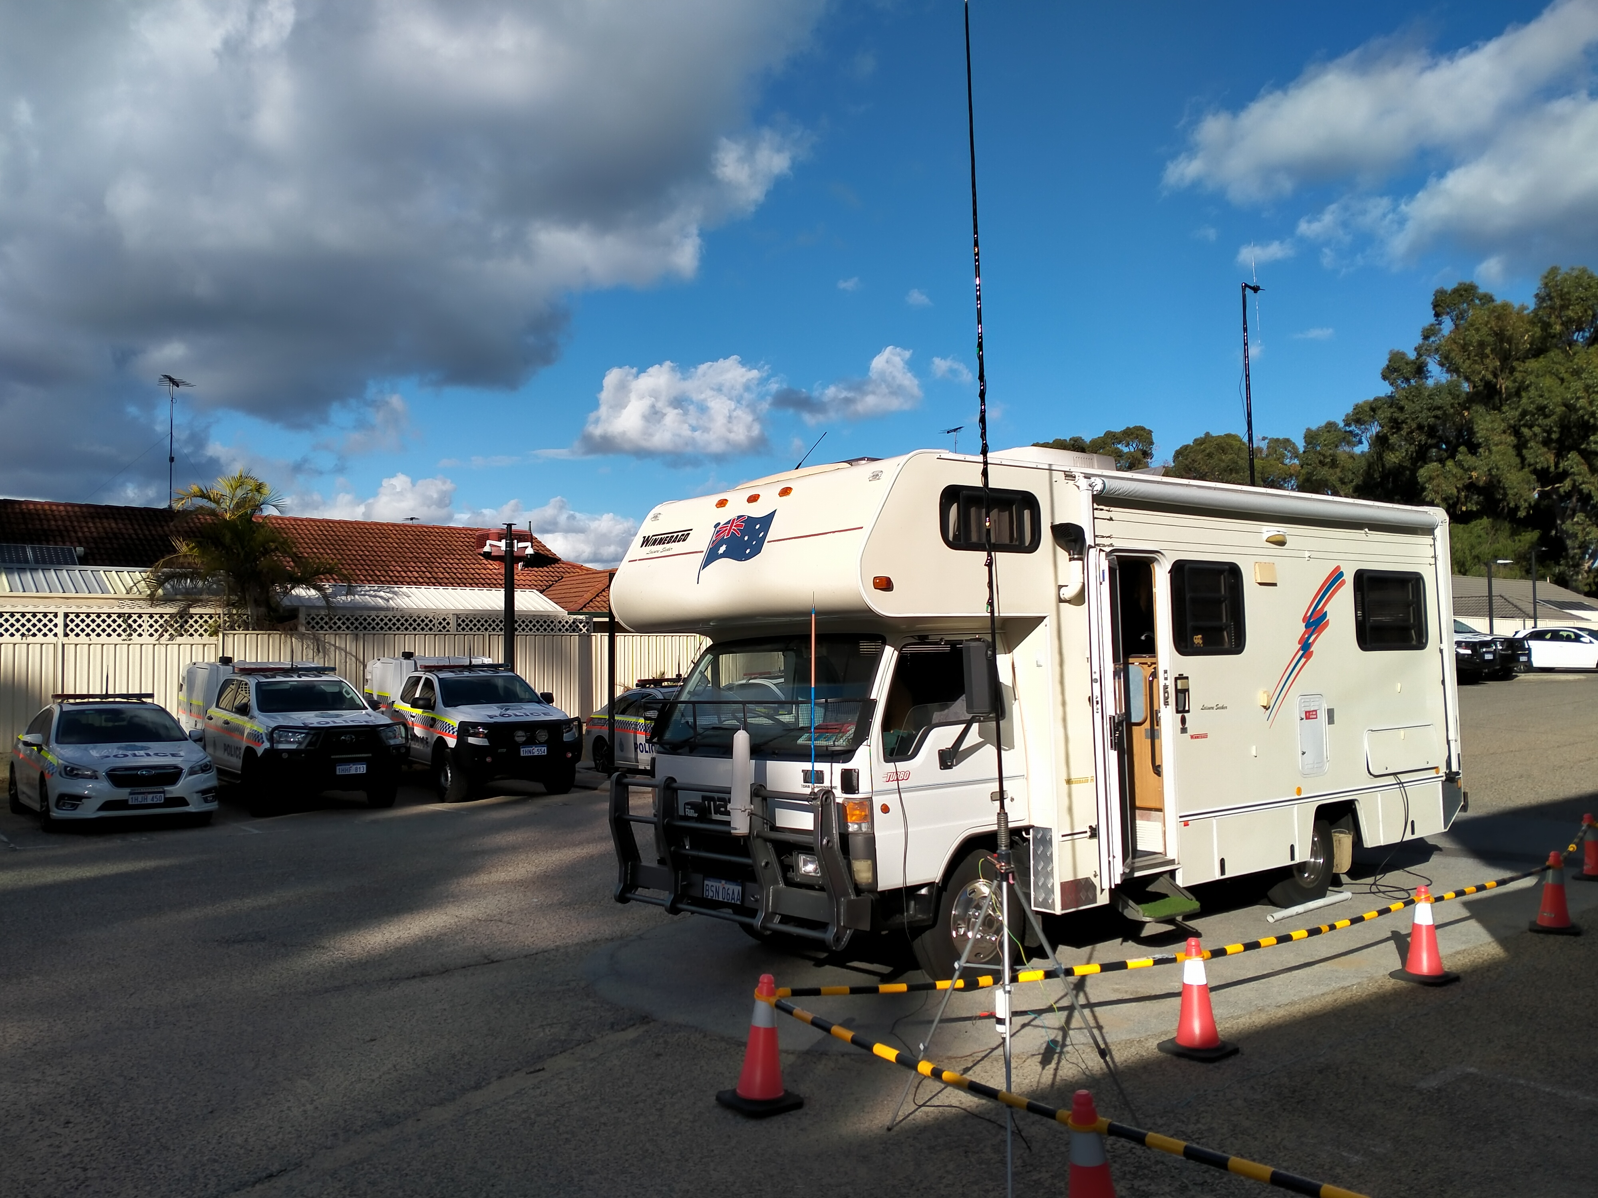

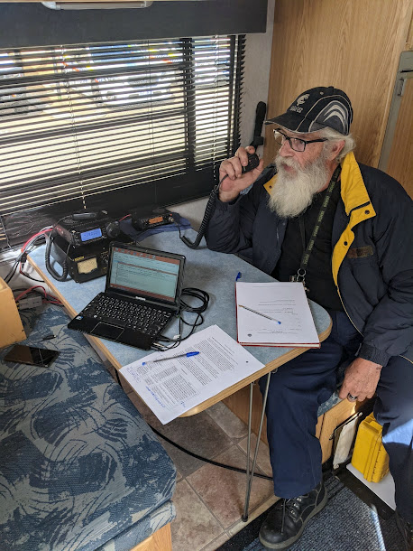
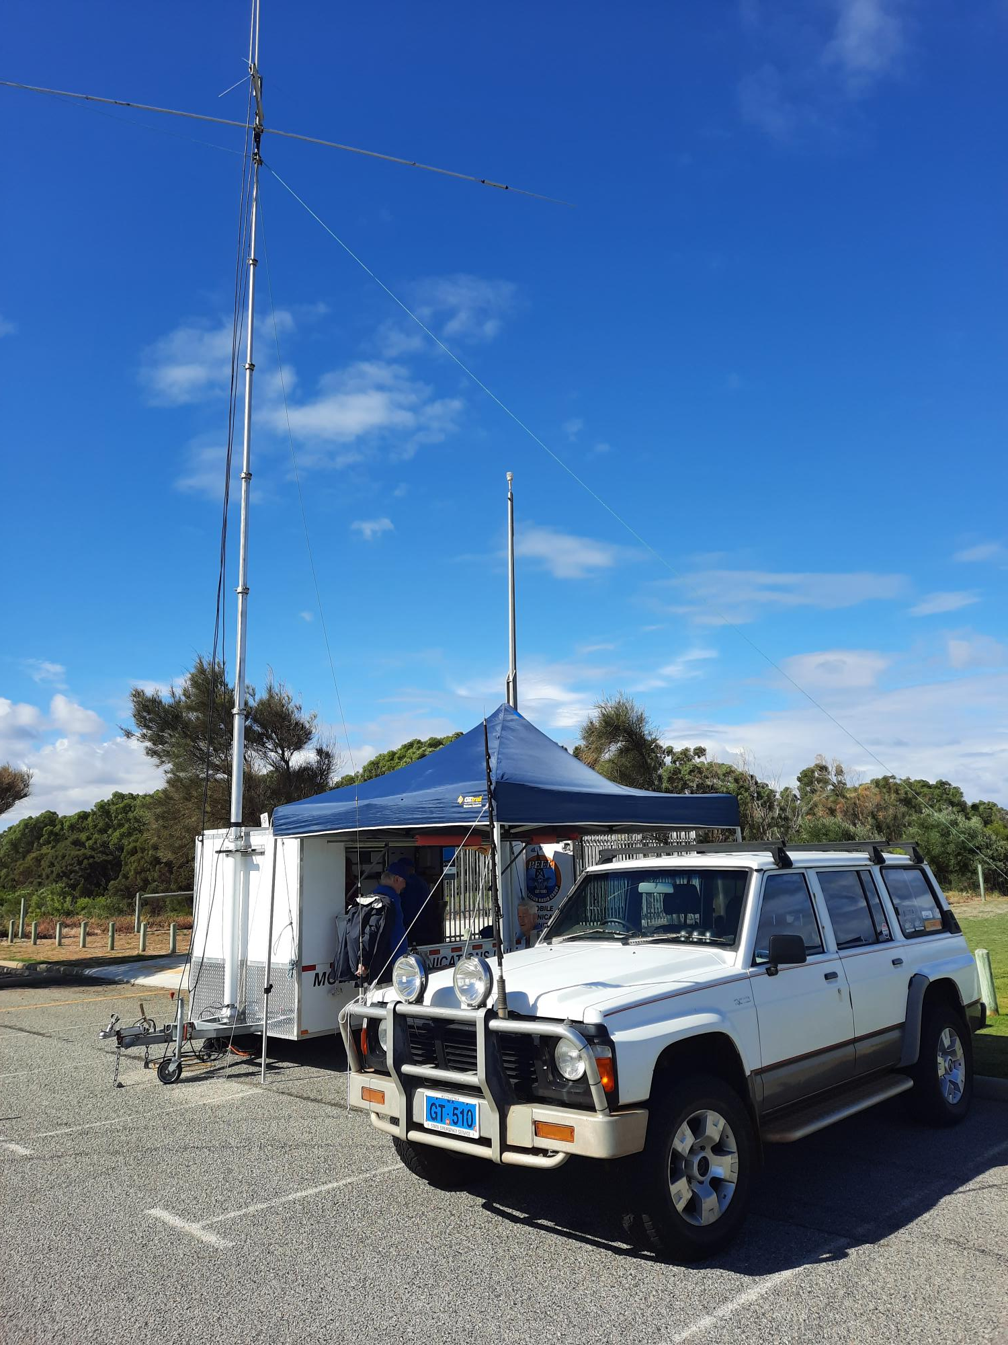

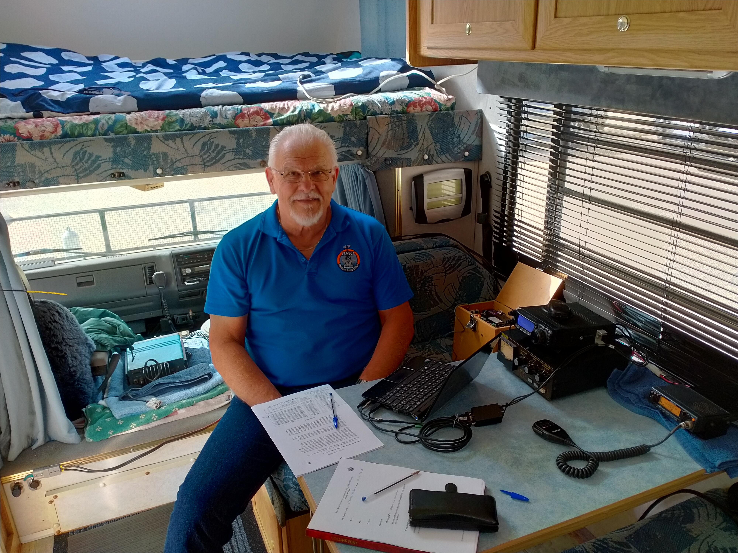
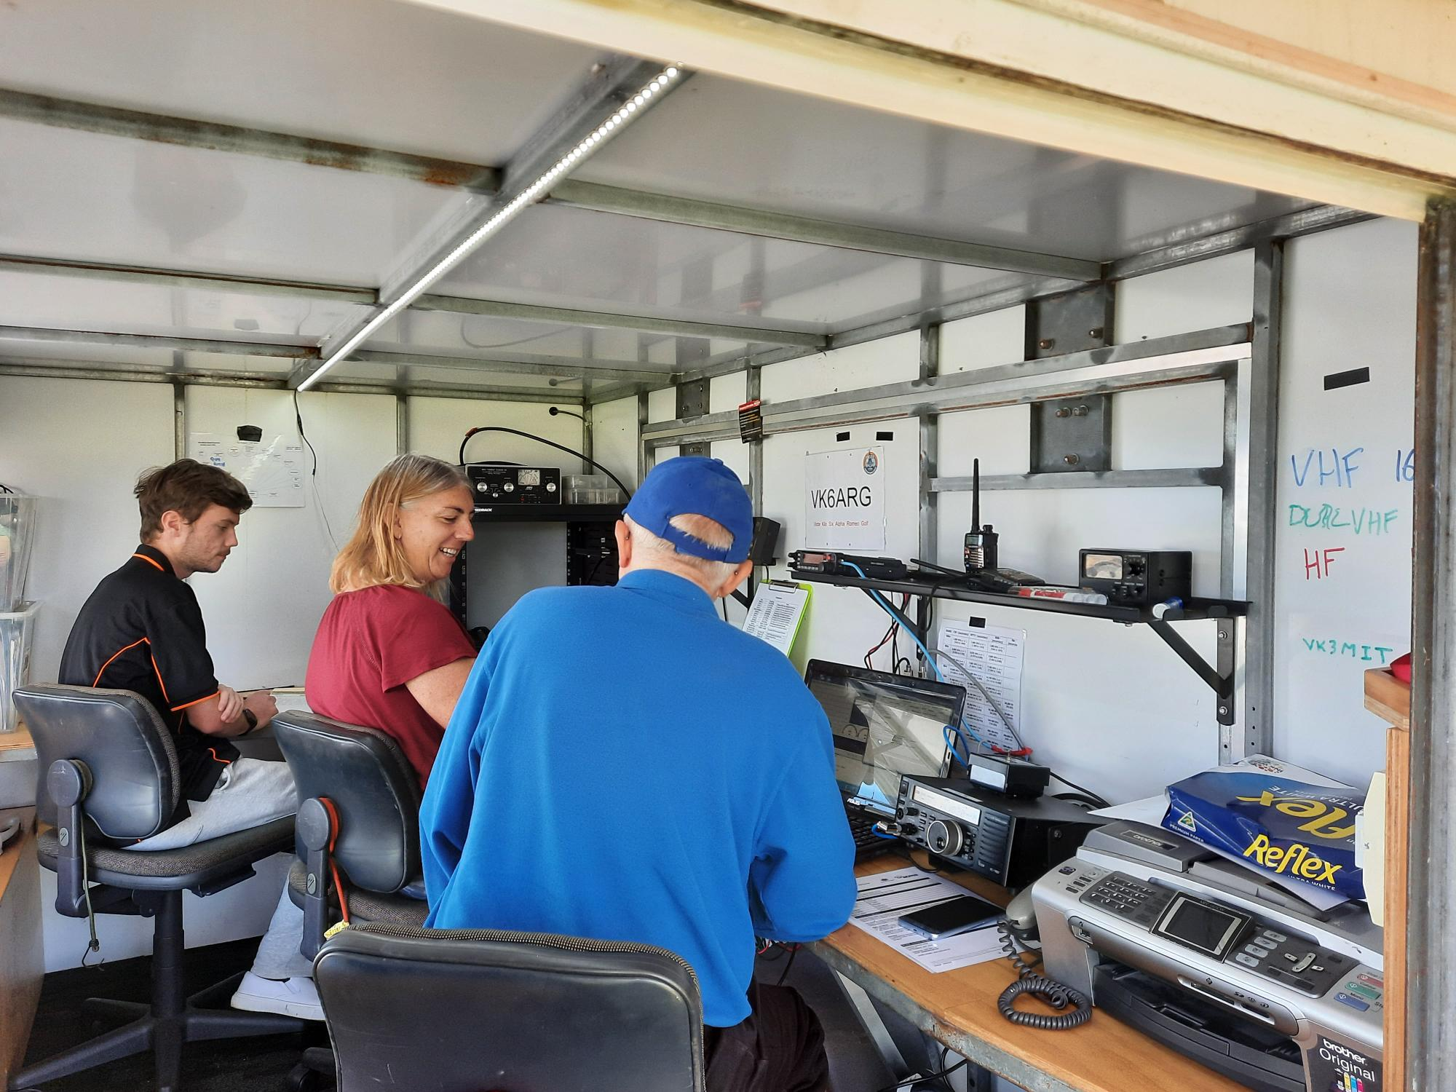

References
1. City of Mandurah – Local Emergency Plans – General Plan 2018.
2. https://aso.gov.au/titles/radio/cyclone-tracy-1974/notes/
3. Lessons learned from PARGESS emergency communications exercise – 18May19.

